Experiment - 7
Operating Systems Lab
Syeda Reeha Quasar
14114802719
6C7
AIM
Write a program to implement reader/writer problem using semaphore.

EXPERIMENT – 7

Aim:
Write a program to implement reader/writer problems using semaphore.

Theory:
The readers-writers problem is a classical problem of process synchronization; it relates to a data set such as a file that is shared between more than one process at a time.
Among these various processes, some are Readers - which can only read the data set they do not perform any updates, some are Writers – who can both read and write in the data sets.
The readers-writers problem is used for managing synchronization among various reader and writer processes so that there are no problems with the data sets, i.e., no inconsistency is generated.
A semaphore is simply an integer variable that is shared between threads. This variable is used to solve the critical section problem and to achieve process synchronization in the multiprocessing environment.

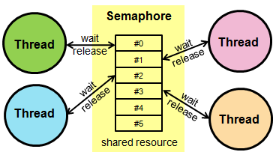

Source Code:

function sem_wait(){
while [ $1 -le 0 ]
do
$1=$(($1-1))
done
}

function signal(){
result=$(($1+1))
}

x=1 y=1 z=1
wsem=1 rsem=1 readcount=0 writecount=0 var=5

function reader(){
echo "----------------------------"
echo "reader " $1 " is reading"
sem_wait $z
sem_wait $rsem
sem_wait $x
readcount=$((readcount+1))
if [ $readcount -eq 1 ]
then
sem_wait $wsem
fi
signal $x
signal $rsem
signal $z
echo "Updated value = " $var
sem_wait $x
readcount=$((readcount-1))
if [ $readcount -eq 0 ]
then
signal $wsem
fi
signal $x
}

function writer(){
echo
echo "writer " $1 " is writing"
sem_wait $y
writecount=$((writecount+1))
if [ $writecount -eq 1 ]
then
sem_wait $rsem
fi
signal $y
sem_wait $wsem
var=$((var+5))
signal $wsem
sem_wait $y
writecount=$((writecount-1))
if [ $writecount -eq 0 ]
then
signal $rsem
fi
signal $y
}

reader 0
writer 0
reader 1
reader 2
reader 3
writer 3
reader 4

Output:

